**Assignment 5**

**Name – SURAJ KUMAR YADAV**

**ROLL NO. – 20220PHY014**

1. **Design a 4 to 1 MUX**

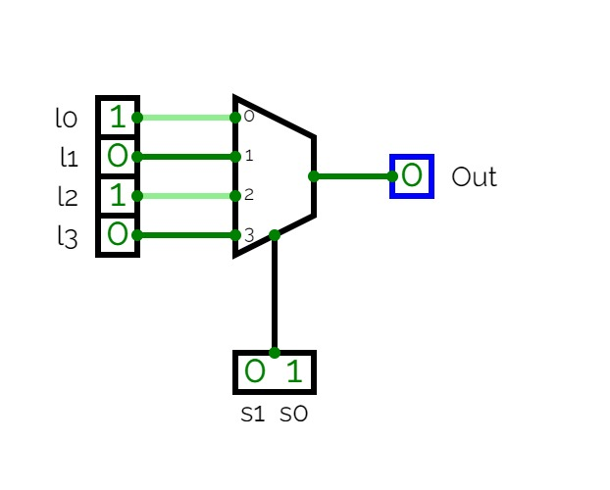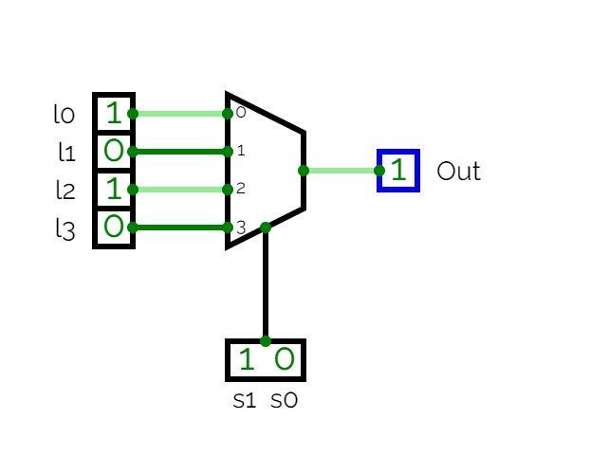

1. **Implement Boolean function F(A, B, C) = ∑(1, 3, 5, 6) using 4:1 MUX**

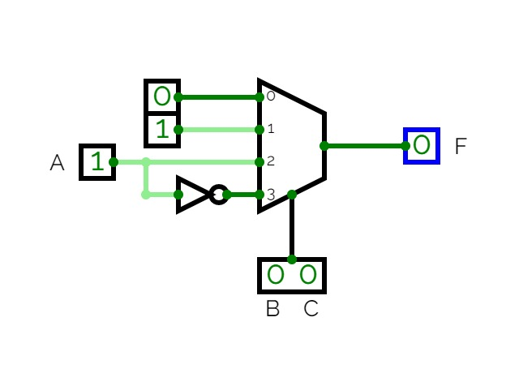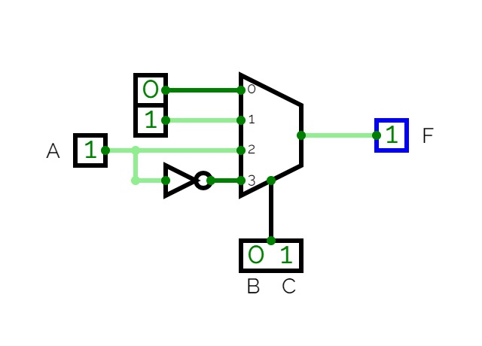

1. **Construct a 32:4 ROM**

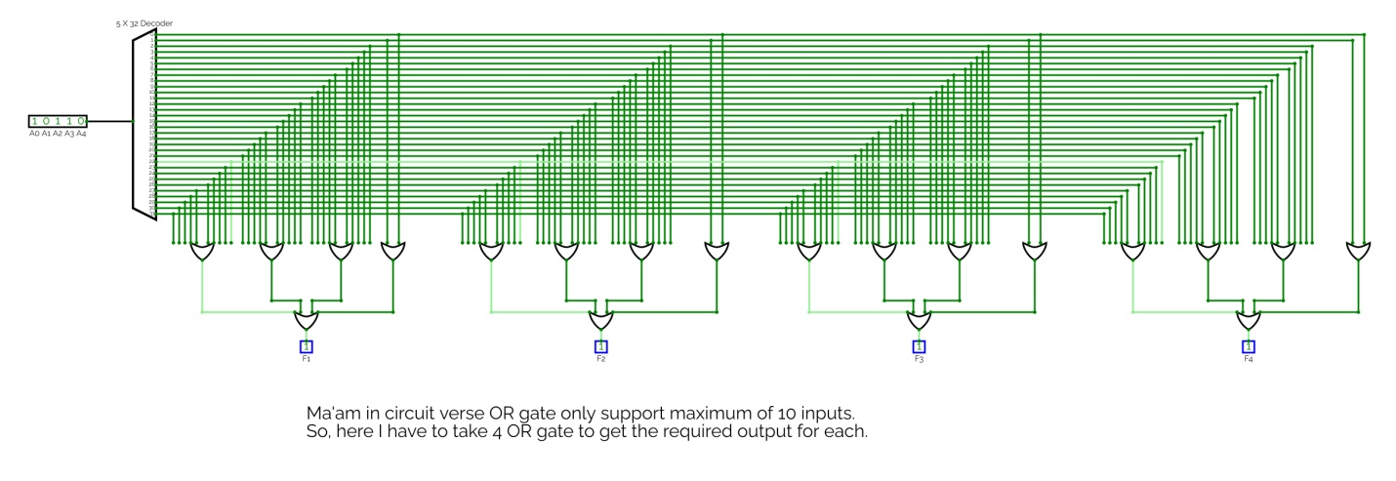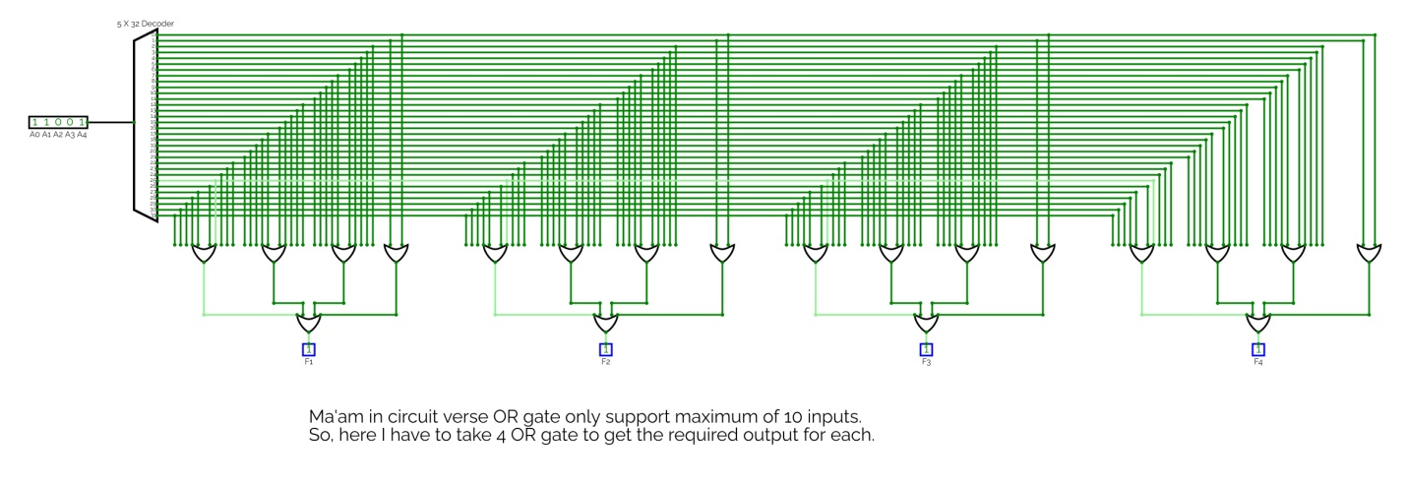

1. **Design a combinational circuit using ROM that accepts 2 bit number and generates output binary number equal to the square of the input number.**

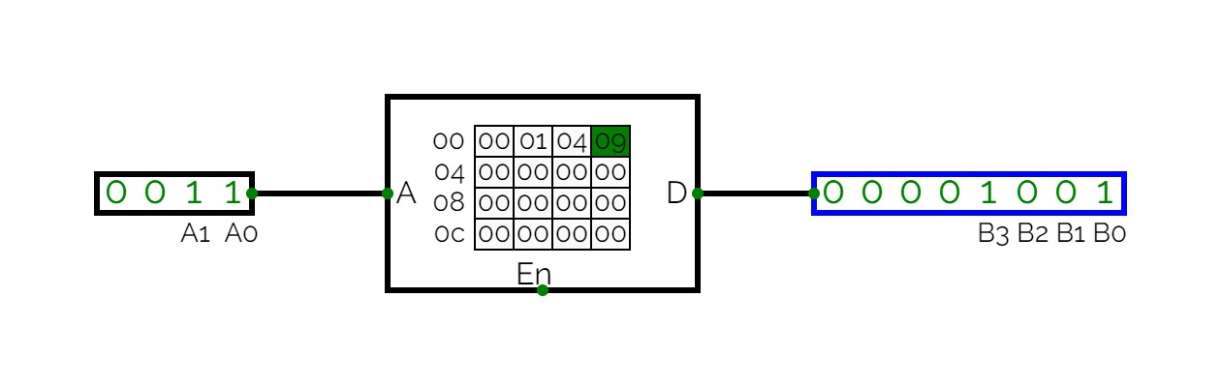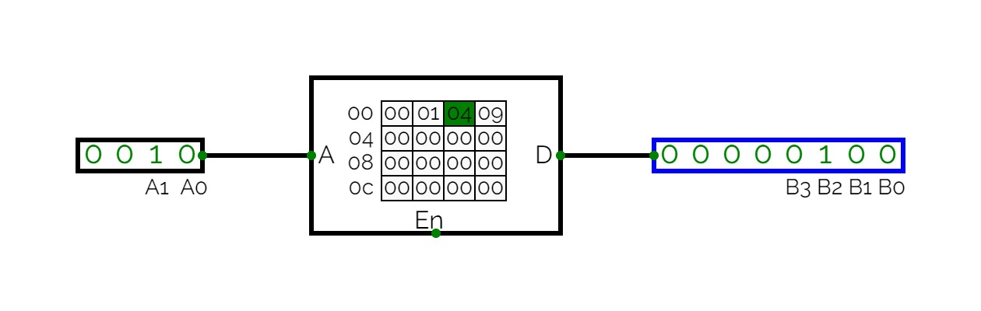

1. **Design a PAL and PLA circuits for the combinational circuit discussed in class.**
   1. **PAL circuit**

w(A, B, C, D) = ∑(2, 12, 13) 🡪 w = ABC’ + A’B’CD’

x(A, B, C, D) = ∑(7, 8, 9, 10, 11, 12, 13, 14, 15) 🡪 x = A + BCD

y(A, B, C, D) = ∑(0, 2, 3, 4, 5, 6, 7, 8, 10, 11, 15) 🡪 y = A’B + CD + B’D’

z(A, B, C, D) = ∑(1, 2, 8, 12, 13) 🡪 z = w + AC’D’ + A’B’C’D

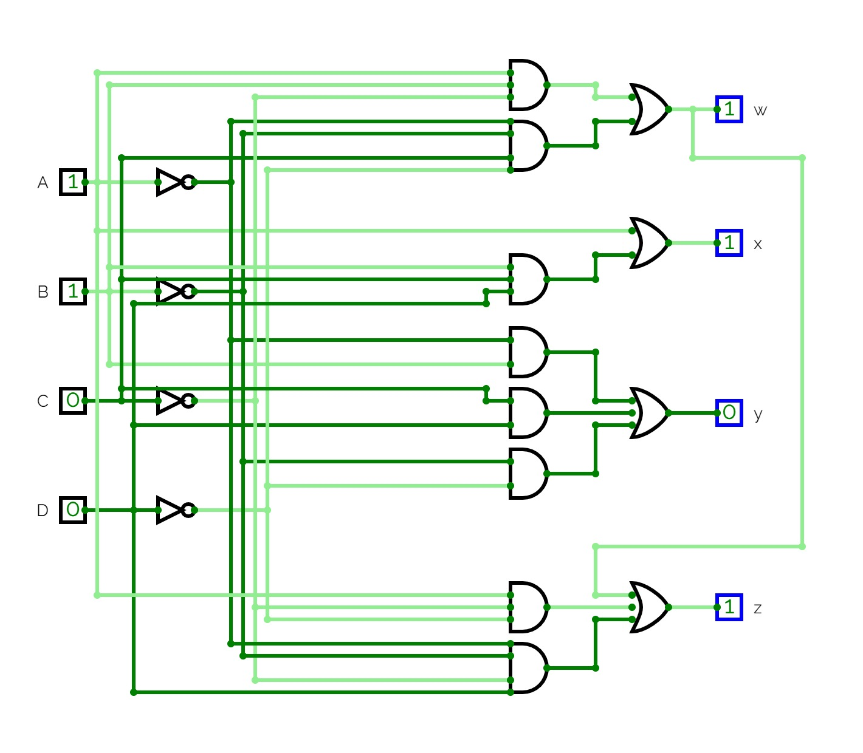

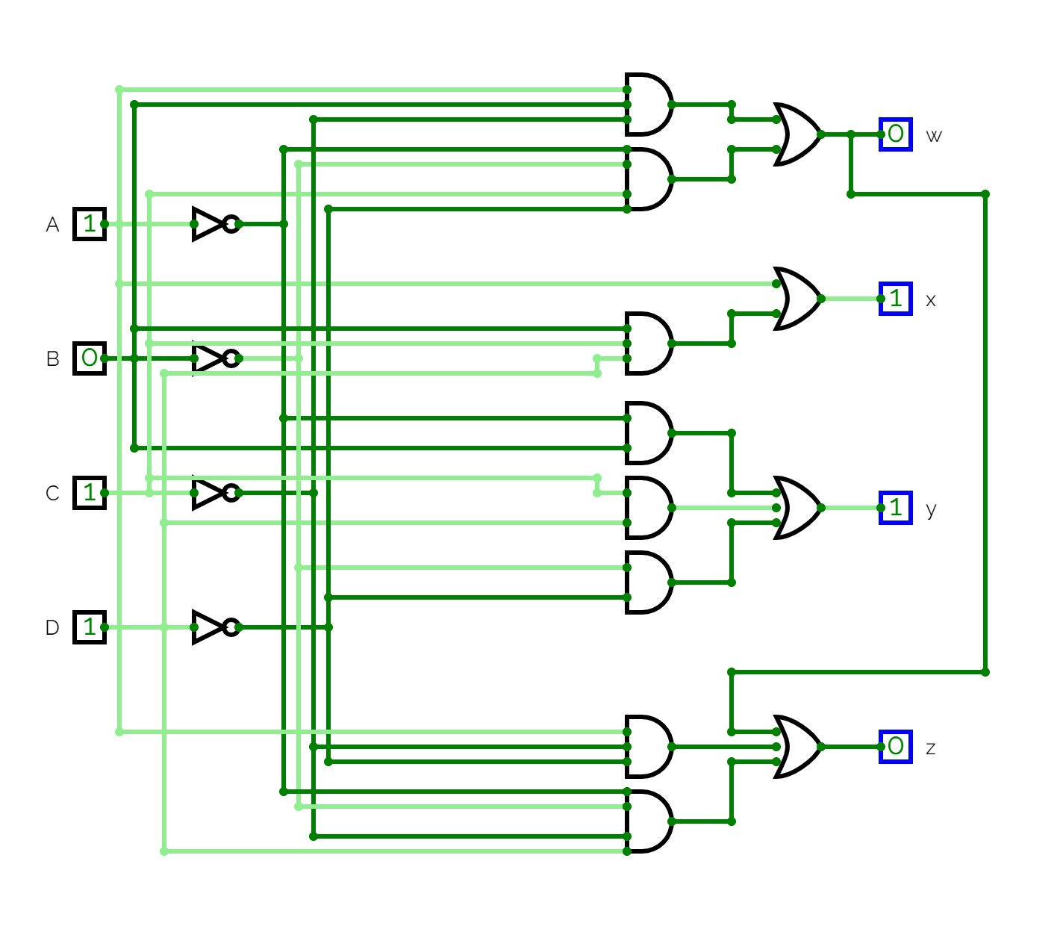

* 1. **PLA circuit**

F1(A, B, C) = ∑(4, 5, 7) 🡪 F1 = AB’ + AC

F2(A, B, C) = ∑(3, 5, 7) 🡪 F2 = AC + BC

